**Q1. Create a layout using RelativeLayout with a TextView centered on the screen and a Button below it.**

Solution:

**activity_main.xml –**

<?xml version="1.0" encoding="utf-8"?>  
<androidx.constraintlayout.widget.ConstraintLayout xmlns:android="http://schemas.android.com/apk/res/android"  
 xmlns:app="http://schemas.android.com/apk/res-auto"  
 xmlns:tools="http://schemas.android.com/tools"  
 android:id="@+id/main"  
 android:layout_width="match_parent"  
 android:layout_height="match_parent"  
 tools:context=".MainActivity">  
 <RelativeLayout  
 android:layout_width="match_parent"  
 android:layout_height="match_parent"  
 tools:layout_editor_absoluteX="-66dp"  
 tools:layout_editor_absoluteY="0dp">  
  
 <TextView  
 android:id="@+id/textView1"  
 android:layout_width="wrap_content"  
 android:layout_height="wrap_content"  
 android:text="Hello Everyone"  
 android:layout_centerVertical="true"  
 android:layout_centerHorizontal="true" />  
  
 <Button  
 android:layout_width="128dp"  
 android:layout_height="wrap_content"  
 android:layout_alignParentBottom="true"  
 android:layout_centerHorizontal="true"  
 android:layout_marginBottom="284dp"  
 android:text="my button" />  
 </RelativeLayout>

**Output:**

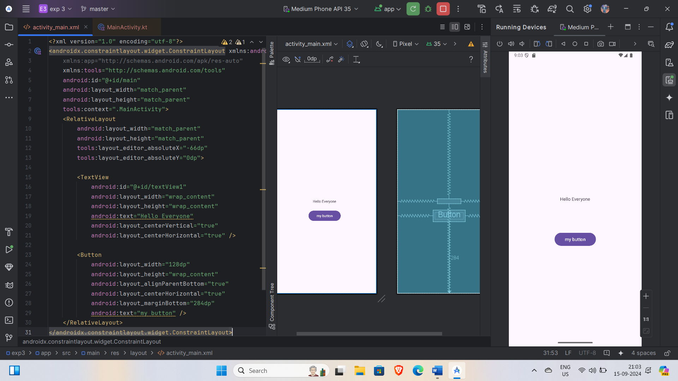

**Q2. Design a form using TableLayout with labels and input fields.**

Solution:

**activity_main.xml -**

<?xml version="1.0" encoding="utf-8"?>  
<androidx.constraintlayout.widget.ConstraintLayout xmlns:android="http://schemas.android.com/apk/res/android"  
 xmlns:app="http://schemas.android.com/apk/res-auto"  
 xmlns:tools="http://schemas.android.com/tools"  
 android:id="@+id/main"  
 android:layout_width="match_parent"  
 android:layout_height="match_parent"  
 tools:context=".MainActivity">  
  
 <TableLayout  
 android:id="@+id/tableLayout"  
 android:layout_width="match_parent"  
 android:layout_height="wrap_content"  
 android:layout_centerHorizontal="true"  
 app:layout_constraintBottom_toBottomOf="parent"  
 app:layout_constraintTop_toTopOf="parent">  
  
 <TableRow>  
  
 <TextView  
 android:layout_width="108dp"  
 android:layout_height="wrap_content"  
 android:text="Enter name" />  
  
 <EditText  
 android:id="@+id/editTextText1"  
 android:layout_width="wrap_content"  
 android:layout_height="wrap_content"  
 android:ems="10"  
 android:inputType="text"  
 android:text=""  
 android:hint="Enter your name"  
 tools:layout_editor_absoluteX="35dp"  
 tools:layout_editor_absoluteY="135dp" />  
 </TableRow>  
  
 <TableRow>  
  
 <TextView  
 android:layout_width="wrap_content"  
 android:layout_height="wrap_content"  
 android:text="Enter password" />  
  
 <EditText  
 android:id="@+id/editTextTextPassword1"  
 android:layout_width="wrap_content"  
 android:layout_height="wrap_content"  
 android:ems="10"  
 android:inputType="textPassword"  
 android:hint="Enter a 8-character long password"  
 tools:layout_editor_absoluteX="59dp"  
 tools:layout_editor_absoluteY="178dp" />  
 </TableRow>  
  
 <TableRow>  
  
 <TextView  
 android:layout_width="wrap_content"  
 android:layout_height="wrap_content"  
 android:text="Renter password" />  
  
 <EditText  
 android:id="@+id/editTextTextPassword2"  
 android:layout_width="wrap_content"  
 android:layout_height="wrap_content"  
 android:ems="10"  
 android:inputType="textPassword"  
 android:hint="Renter the entered password"  
 tools:layout_editor_absoluteX="59dp"  
 tools:layout_editor_absoluteY="178dp" />  
 </TableRow>  
  
 <TableRow>  
  
 <TextView  
 android:layout_width="wrap_content"  
 android:layout_height="wrap_content"  
 android:text="Enter Phone" />  
  
 <EditText  
 android:id="@+id/editTextTextNumber"  
 android:layout_width="wrap_content"  
 android:layout_height="wrap_content"  
 android:ems="10"  
 android:inputType="textPassword"  
 android:hint="Enter a valid phone number"  
 tools:layout_editor_absoluteX="59dp"  
 tools:layout_editor_absoluteY="178dp" />  
 </TableRow>  
  
 <TableRow>  
  
 <TextView  
 android:layout_width="wrap_content"  
 android:layout_height="wrap_content"  
 android:text="Enter email" />  
  
 <EditText  
 android:id="@+id/editTextTextEmailAddress"  
 android:layout_width="wrap_content"  
 android:layout_height="wrap_content"  
 android:ems="10"  
 android:hint="Your valid email address"  
 android:inputType="textEmailAddress"  
 tools:layout_editor_absoluteX="64dp"  
 tools:layout_editor_absoluteY="124dp" />  
 </TableRow>  
  
 <TableRow>  
  
 <Button  
 android:id="@+id/button"  
 android:layout_width="wrap_content"  
 android:layout_height="wrap_content"  
 android:layout_span="2"  
 android:text="Submit form"  
 tools:layout_editor_absoluteX="95dp"  
 tools:layout_editor_absoluteY="158dp" />  
 </TableRow>  
 </TableLayout>  
  
 <TextView  
 android:id="@+id/textView"  
 android:layout_width="wrap_content"  
 android:layout_height="wrap_content"  
 android:text="User form by Me"  
 android:textColor="#9C27B0"  
 android:textSize="24sp"  
 android:textStyle="bold"  
 app:layout_constraintBottom_toBottomOf="parent"  
 app:layout_constraintEnd_toEndOf="parent"  
 app:layout_constraintHorizontal_bias="0.497"  
 app:layout_constraintStart_toStartOf="parent"  
 app:layout_constraintTop_toTopOf="parent"  
 app:layout_constraintVertical_bias="0.149" />  
  
  
</androidx.constraintlayout.widget.ConstraintLayout>

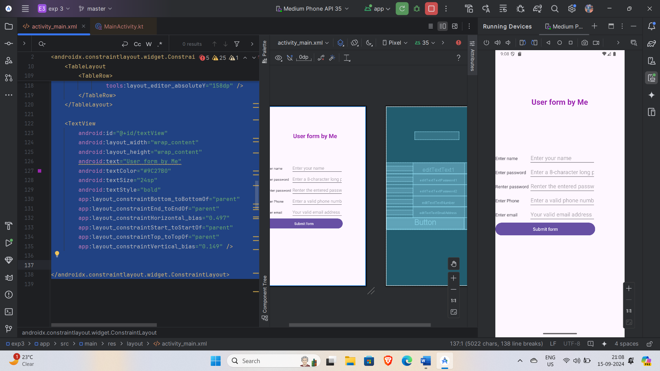

**Q3. Implement a complex screen using FrameLayout and ScrollView to understand layering and scrolling.**

Solution:

**activity_main.xml –**

<?xml version="1.0" encoding="utf-8"?>  
<FrameLayout xmlns:android="http://schemas.android.com/apk/res/android"  
 xmlns:tools="http://schemas.android.com/tools"  
 android:id="@+id/main"  
 android:layout_width="match_parent"  
 android:layout_height="match_parent"  
 tools:ignore="ExtraText">  
  
 <ScrollView  
 android:layout_width="match_parent"  
 android:layout_height="match_parent"  
 android:fillViewport="true">  
  
 <LinearLayout  
 android:layout_width="match_parent"  
 android:layout_height="wrap_content"  
 android:orientation="vertical"  
 android:padding="16dp">  
  
 <TextView  
 android:layout_width="wrap_content"  
 android:layout_height="wrap_content"  
 android:padding="16dp"  
 android:text="Scrollable Content"  
 android:textColor="@android:color/black"  
 android:textSize="18sp" />  
  
 <ImageView  
 android:layout_width="match_parent"  
 android:layout_height="200dp"  
 android:layout_marginBottom="16dp"  
 android:scaleType="centerCrop"  
 android:src="@android:drawable/ic_menu_gallery"  
 tools:srcCompat="@tools:sample/backgrounds/scenic[7]" />  
  
 <TextView  
 android:layout_width="wrap_content"  
 android:layout_height="wrap_content"  
 android:padding="16dp"  
 android:text="This is more scrollable text"  
 android:textColor="@android:color/black"  
 android:textSize="18sp" />  
  
 <ImageView  
 android:layout_width="match_parent"  
 android:layout_height="200dp"  
 android:layout_marginBottom="16dp"  
 android:scaleType="centerCrop"  
 android:src="@android:drawable/ic_menu_camera"  
 tools:srcCompat="@tools:sample/backgrounds/scenic[3]" />  
  
 </LinearLayout>  
 </ScrollView>  
  
 <TextView  
 android:layout_width="wrap_content"  
 android:layout_height="wrap_content"  
 android:layout_gravity="center_horizontal|top"  
 android:layout_marginTop="20dp"  
 android:background="#80000000"  
 android:padding="8dp"  
 android:text="Layered Text on Top"  
 android:textColor="@android:color/white"  
 android:textSize="24sp" />  
  
 <ImageView  
 android:layout_width="100dp"  
 android:layout_height="100dp"  
 android:layout_gravity="bottom|center_horizontal"  
 android:layout_marginBottom="30dp"  
 android:src="@android:drawable/ic_menu_compass"  
 tools:srcCompat="@tools:sample/avatars[8]" />  
  
</FrameLayout>

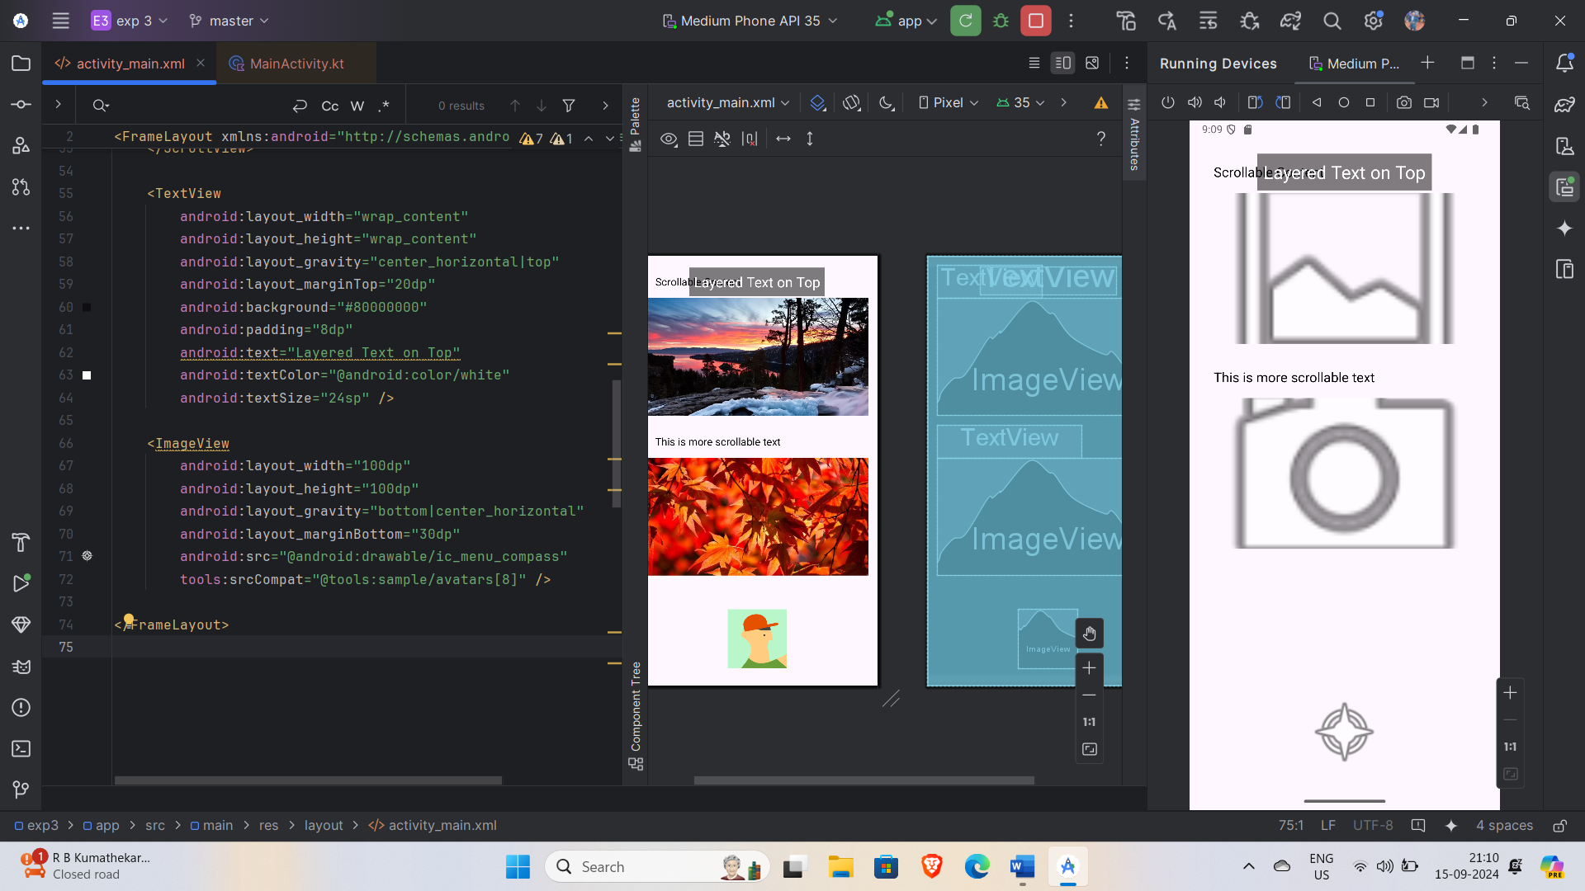

**Q4. Implement a complex screen using Grid Layout.**

Solution:

**activity_main.xml –**

<GridLayout  
 xmlns:android="http://schemas.android.com/apk/res/android"  
 android:layout_width="match_parent"  
 android:layout_height="match_parent"  
 android:rowCount="2"  
 android:columnCount="2">  
 <TextView  
 android:layout_width="wrap_content"  
 android:layout_height="wrap_content"  
 android:text="Row 1, Col 1"  
 android:layout_row="0"  
 android:layout_column="0" />  
 <TextView  
 android:layout_width="wrap_content"  
 android:layout_height="wrap_content"  
 android:text="Row 1, Col 2"  
 android:layout_row="0"  
 android:layout_column="1" />  
 <Button  
 android:layout_width="wrap_content"  
 android:layout_height="wrap_content"  
 android:text="Row 2, Col 1"  
 android:layout_row="1"  
 android:layout_column="0" />  
 <Button  
 android:layout_width="wrap_content"  
 android:layout_height="wrap_content"  
 android:text="Row 2, Col 2"  
 android:layout_row="1"  
 android:layout_column="1" />  
</GridLayout>

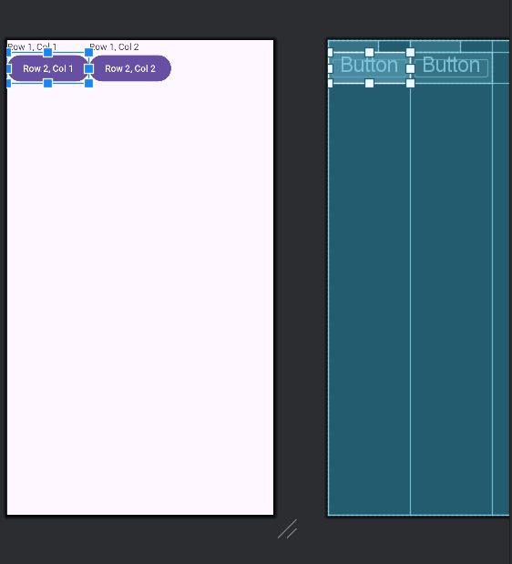

**Q4. Implement Linear Layout.**

Solution:

**activity_main.xml –**

<?xml version="1.0" encoding="utf-8"?>  
<androidx.constraintlayout.widget.ConstraintLayout xmlns:android="http://schemas.android.com/apk/res/android"  
 xmlns:app="http://schemas.android.com/apk/res-auto"  
 xmlns:tools="http://schemas.android.com/tools"  
 android:id="@+id/main"  
 android:layout_width="match_parent"  
 android:layout_height="match_parent"  
 tools:context=".MainActivity">  
  
  
<LinearLayout  
 xmlns:android="http://schemas.android.com/apk/res/android"  
 android:layout_width="match_parent"  
 android:layout_height="match_parent"  
 android:orientation="vertical">  
 <TextView  
 android:layout_width="wrap_content"  
 android:layout_height="wrap_content"  
 android:text="TextView 1" />  
 <Button  
 android:layout_width="wrap_content"  
 android:layout_height="wrap_content"  
 android:text="Button 1" />  
</LinearLayout>  
   
</androidx.constraintlayout.widget.ConstraintLayout>

